

You will need:

Paper

Pencil

Calculator



**Seeing Double**

(If you don’t have a calculator, there are lots online that you can use!)

* Start with 1, double it, double it again and again……and so on!
* Look at the units digit of your answers. Can you see a pattern?
* Now start with 3 and keep doubling. What happens this time?
* Start with 5 and keep doubling. What do you notice?
* Start with 7 and keep doubling. What patterns do you notice?



**Going Further**

* 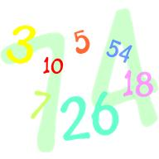Choose other starting numbers and keep doubling. Record what happens. Can you find starting numbers that produce the same patterns?