Week 8
Literacy | Revise sounds ‘e,h,r,m’. using the activities suggested on P1 school website page and complete the activities allocated on Education City/Seesaw.  Introduce the capital letter and letter name for each sound.  High Frequency Words: ‘get’ and ‘up’  Reading: See GR books allocated through SeeSaw  Handwriting: ‘n’ and ‘h’  Listen to the story of ‘Fidgety Fish’ on Youtube: https://www.youtube.com/watch?v=TLW_jwXgbRg and discuss it with your child, talking about what happened at the beginning, middle and end of the story. Encourage your child to make a story map by drawing and writing about the events in order. If you have a printer you can download and print the template from our class webage this week; if not then you could just use a ruler to divide a page in your child’s literacy book into 3 sections.
Numeracy | Mental maths: ask your child one less than a number within 15. For example, “What is one less than 4?”  Double up to 5+5. Using all practical objects to help. For example, 1 crayon plus 1 crayon = 2 crayons. Then ask the children to record onto a page or whiteboard or sticky note 1+1=2.  Why not get creative and make a ‘function machine’?  Here is an idea:  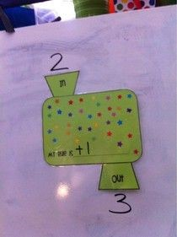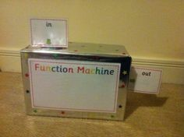  In the middle of the box, write the ‘rule’ I.e. add 1. Children can use toy cars, pegs, marbles, magnetic numbers or write the number. If number 2 goes ‘into’ the machine, add 1, out will come number 3. Continue with adding 2 as the rule. By the end of the week, give the children the ‘in’ number and ‘out’ number and see if they can guess what the rule was.  Complete the numeracy workbook page and activity allocated on SeeSaw.
Topic | Research some famous pirates using the ‘Famous Pirates’ PowerPoint on our webpage as a starting point.  Create a wanted poster for one of the pirates that you have found out about (or one that you have made up!) Include a drawing of the pirate, a description of what he or she looks like, and of course a reward!  Learn the Pirate Jobs Song (using the PowerPoint on the website) and sing it while doing the actions.
Grow in Love | Log on to the Grow in Love website:  Username: trial@growinlove.ie  Password: growinlove  Select P1. Go to: Theme 8 ‘Water’, Lesson 2: ‘Welcomed with Water’.  Watch video ‘Baptism’. Chat with your child about how they were welcomed into the Catholic Church with Water during their Baptism. Show your child photographs of their Baptism and explain that it was a very special day for all of the family to celebrate with God.  Complete ‘Baptism’ activity sheets sent to you on Seesaw.  Watch video ‘Holy Water’

