Literacy  - Reading:  Keep working hard to reach your target and if you have done so already make sure you are reading 15 mins every day!  - Accelerated Reader: quizzes can still be completed Monday-Friday, 9am-3pm. Remember to use https://readon.myon.co.uk for a large selection of FREE online AR books!  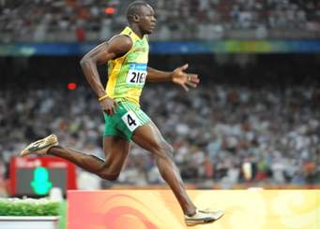  - Comprehension Task  ‘Usain Bolt’  Look for the star rating at the bottom of the page;  - Sent via Seesaw | Numeracy  - Times Table ROCKSTARS:  - Keep practising your tables on our Times Tables Rockstars website! We will need all the help we can get to win 3 in a row!  - Rockstar battle vs Miss Dohertys’s class will take part as usual at 12pm on Friday!  - Sports Day MATHS CHALLENGE:  ‘The Mystery of the Missing Sacks on Sports Day’  Follow the instructions and solve the clues to work out who the culprit was! | No Homework this week! 😊
Other fun activites to complete:  - Design a Sports Day medal.  - What discipline will your medal be awarded? Winning? Taking part? Good sportsmanship?  - Mindfulness colouring in.  - Can you take some time to carefully colour in the Sports Day pictures? Why not listen to some relaxation music while doing so? Send me your favourite picture on Seesaw once you have coloured it in!  - Sports Day word search.  - Can you find all the Sports Day words? | As Monday 25th May is a Bank Holiday and school would have been closed until Wednesday, activities/tasks are reduced this week.  We encourage you to complete some of our fun tasks this week 😊  Our virtual SPORTS DAY video will be shown on Friday!  Rockstar battle vs Miss Doherty’s class will take part as usual at 12pm on Friday! | 😊 Our SPORTS DAY challenges! 😊  Send your photos and videos to us by Thursday 28th May, to be included in our ‘Virtual Sports Day’ showcase!! You can race any of your adults or siblings at home or try to make a personal best for yourself!  We can’t wait to see all your challenges!  Remember our 3 challenges…  - Running  - Potato & Spoon  - Design & test your own Obstacle course  