Literacy  Reading: Continue to read at home and take AR quizzes  https://ukhosted3.renlearn.co.uk/2235372/default.aspx  Monday: Spelling Activity:  Please refer to See Saw for Group Tasks  Tuesday: Grammar: Identifying Prepositions  Link: https://www.youtube.com/watch?v=WFiNljxsN5o  Please refer to See Saw for Group Tasks  Wednesday: Writing: Creative Writing  Group 1 Group 2 Group 3 Group 4  Write a story that begins with the line: I had never seen anything so disgusting in my life We turned the corner and saw a spooky dark house Island Write about a time when you felt happy  Group 1 and Group 4: Please complete the Creative Writing Activity in your Literacy Book. Thank you  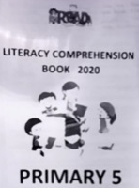  Thursday: Comprehension:  Please complete a comprehension from the ‘Literacy Comprehension Booklet’ – this booklet was sent home.  Friday: Friday Test  Ask an adult or sibling to test you!  Handwriting – Try writing your spelling list in cursive script | Numeracy  Monday: Sequences  Link: https://www.youtube.com/watch?v=ohPSbZKyxx8  Please refer to See Saw for Group Tasks  Tuesday: Tables and Tallies  Link: https://www.youtube.com/watch?v=6L2ch1esFGA  Please refer to See Saw for Group Tasks  Wednesday:  Times Tables Rock Stars or Numbots  Thursday: Bar Charts  Link: https://www.youtube.com/watch?v=3e1SIAPan8E  Please refer to See Saw for Group Tasks  Friday: Weekly Challenge!  Ask an adult or sibling to test you!  Homework  Monday Reading Spellings Number facts  EIP day 121 MA S3 Test 7a MA Monday ABC order  Tuesday Reading Spellings Number facts  EIP day 122 MA S3 Test 7b MA Tuesday Rainbow  Wednesday Reading Spellings Number facts  EIP day 123 MA S3 Test 7c MA Wednesday V and C  Thursday Reading Spellings Number facts  EIP day 124 Calculations Practice Test | Other Curriculum Areas  Topic: Natural Disasters/ Extreme Earth  Volcanoes  A volcano is a landform (usually a mountain) where molten rock erupts through the surface of the planet.  We would like you to try:  - Labelling a cross section of a volcano  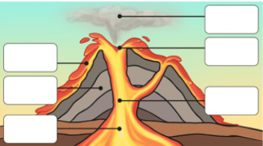  - An Experiment: carry out an investigation, can you make your very own erupting volcano?  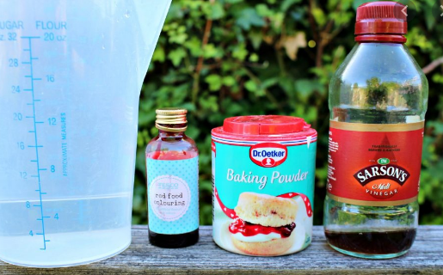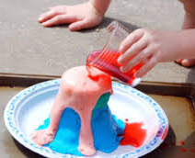  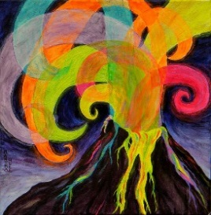  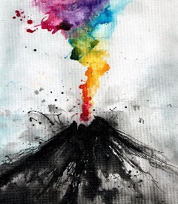  - Drawing a modern-day colourful volcano  Please note that these pictures are only examples, you can carry out your own research too! Don’t forget to send us some videos or photographs on Seesaw!

