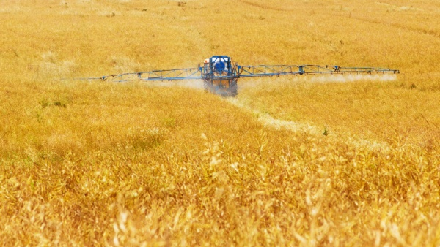

- If 100 litres of spray is needed on every hectare of land, how many hectares can be sprayed with 400 litres?

- Every 100 litres of water in the tank needs to be mixed with 4 litres of spray chemical. How much spray chemical is needed when 500 litres are in the tank?

- Farmer Fred sells his old tractor for £2,000 and he buys a new tractor for £19,000. How much extra money does he need to find?

- Fred sells his old combine for £200,000 and wants to buy a new combine for £400,000.
- How much more money does he need?
- He does not have enough money all at once so he agrees to pay half of the cost this year and half next year. How much money does he pay each year?

