**St. Joseph’s P.S.**

**Antrim**

**ATTENDANCE POLICY**



Policy Review Date: September 2022

Date approved by Governors: _____________________

Signature of Chair of Governors: ______________________

Review date: January 2024

**Introduction**

All children of compulsory school age have the right to an efficient full time education, regardless of age, aptitude, ability and any special needs he/she may have. Regular school attendance is essential if a child is to make the most of the educational opportunity available to them. St Joseph’s Primary school takes seriously its responsibility to monitor and promote the regular attendance of all its pupils. It acknowledges that irregular attendance seriously disrupts continuity of learning, undermines educational progress, can lead to underachievement and low attainment and impedes the child’s ability to develop friendship groups within school.

The school aims to ensure that every child feels valued, trusted and will want to come to school so this policy has been devised with reference to our Pastoral Care policies and within the Catholic Ethos of the school. We strive to create a warm welcoming and secure atmosphere and a stimulating and accessible curriculum delivered in a physically clean, bright and attractive environment.

This policy has been developed in consultation with Governors, Teachers, Education Welfare Services, pupils, parents and guardians. It seeks to ensure that all parties involved in the practicalities of school attendance are aware and informed of attendance matters in school and to outline the schools’ commitment to attendance matters. It details the responsibilities of individuals and groups involved and the procedures in place to promote and monitor pupil attendance.

The policy will aim to raise and maintain levels of attendance by:

* Promoting a positive and welcoming atmosphere in which pupils feel safe, secure and valued
* Raising the awareness of the importance of a differentiated and relevant curriculum
* Promoting opportunities to celebrate and reward pupil’s successes and achievements
* Raising awareness of the importance of good attendance
* Ensuring that attendance is monitored effectively and reasons for absences are recorded promptly and consistently.

**The Management of Attendance**

**Pupil Expectations**

* To respect themselves and others
* To do all they can to attend school regularly and punctually
* To inform a trusted adult if they feel that they are being bullied
* To encourage friendship and a sense of belonging
* To be happy and encourage others to feel happy

**Parent/Carers’ Expectations**

Parents/carers have a legal duty to ensure their child of compulsory school age shall receive efficient full time education as stated in the Education and Libraries Order below:

**The Education and Libraries (Northern Ireland) Order 1986**

***Duties of parents to secure full-time education for their children:***

**45.** (1) The parent of every child of compulsory school age shall cause him to receive efficient full-time education suitable to his age, ability and aptitude and to any special educational needs he may have, either by regular attendance at school or otherwise.

(2) The provisions of Schedule 13 shall apply to the enforcement of the provisions of paragraph (1) and a parent who contravenes the provisions of that Schedule shall be guilty of an offence and liable to the penalties provided by paragraph 4 of that Schedule.

**In summary, parents/carers have:**

* Prime responsibility for ensuring their child attends school regularly and punctually.
* Legal responsibility to ensure their children attend school regularly and stay in school.
* Enable children to arrive on time, full school uniform and have what is needed for the school day.

**Parent/Guardian Role**

* To keep requests for their child to be absent to a minimum
* To offer a reason for any period of absence on the first day and give an expected length of absence
* Ensure children arrive on time
* To work with school and EWO to resolve problems that may impede attendance
* To take family holidays during school holiday periods and be aware that requests for authorised holidays during term time cannot be approved
* To celebrate with their child and recognise their successes and achievements.

**What is expected of the school?**

The school will endeavour to provide an environment that is conducive in education every individual pupil. School attendance will be positively supported wherever possible and the promotion of good communication and co-operation between all parties involved will be paramount. The school has a statutory responsibility to record and monitor the punctuality and attendance of pupils for both the morning and afternoon sessions. A register of attendance has to be taken once at the start of the morning session and once during the afternoon session. The register has to record whether a pupil is present, engaged in an approved educational activity off site or absent. If a pupil is absent the register must record whether the absence was authorised or unauthorised. If a pupil is late, the late time will be recorded along with any additional comments.

‘Disguised compliance’1 involves parents and carers appearing to co-operate with professionals in order to allay concerns and stop professional engagement (Reder et al, 1993). Published case reviews highlight the importance of practitioners being able to recognise disguised compliance, establishing the facts and gathering evidence about what is actually happening in a child’s life. Best practice suggest that practitioners should display professional curiosity when working with families and not accept information from parents and carers at face value without investigating further.

1 Learning from case reviews briefings Disguised compliance, NSPCC October 2019

Therefore, in light of absences, the school may seek further evidence beyond the parents’/carers’ word to explain the reason for the absence.

**The Governors’ Role**

* To work within the existing Catholic Ethos of the school to ensure all families feel valued and supported.
* To give a high priority to punctuality and attendance
* To develop procedures that enable the school to identify, follow up and record unauthorised absence, patterns of absence and parent condoned absence with effective monitoring and intervention
* To consistently record authorised and unauthorised absences within the guidance of the 1986 Education and Libraries Order
* To develop a range of effective strategies to follow up intermittent and long term absenteeism and promote good attendance
* To encourage open communication channels between home and school
* To develop procedures for the reintegration of long term absentees
* To develop procedures leading to a formal referral to the EWO
* To adequately provide for pupils with difficulties, within the bounds of resources available, and ensure the appropriate delivery of the curriculum

The Education Authority has a responsibility to provide education and promote regular attendance of all statutory school age children. Through the Education Welfare Service (EWS) the EA provides support to schools and parents to fulfil their legal duty. The EWS is the enforcement agency of the EA and as well as providing guidance and support through its officers may take a parent to court for not fulfilling their duty. The court may fine the parent and put in place a School Attendance Order (SAO) an Education Supervision Order (ESO) or a Parenting Order.

**School Procedures for Recording and Monitoring Attendance Recording**

The class teacher will take a register and record who is present at **8:55am**. Any pupils who are late should then enter through the main entrance. If any pupils arrive late with a parent/guardian, they should notify office staff of the reasons why the child is late. The office staff will record this on SIMS. If a child arrives unaccompanied, the child will notify their class teacher, who will record this on SIMS. This is to ensure that fire regulations are met. The register officially closes at **9:30am** and any pupil arriving after will be marked absent for the session. A reason for the lateness will need to be provided and a decision made by the school to mark it as authorised or unauthorised.

Codes:

**L** - 8:55 – 9:30

**U** - 9:30 onwards

During the morning the absences from that morning and the previous afternoon will be recorded onto SIMS and all present pupils marked present. The offered reasons for any lateness from the previous day or any absences will be assessed and the appropriate code entered into the system. The register is again taken at 1pm/1:20pm on SIMS.

Reasons for absence may be offered verbally by phone, via SeeSaw or by a letter on the child’s return to school. The following reasons are recorded as acceptable for an authorised absence.

* The child is ill or is prevented from attending by unavoidable cause (I)
* The child is absent on days exclusively set apart for religious observance in their particular faith
* The child is absent ‘with leave’. This refers to leave being granted by the school, not by the parent, and would normally relate to no more than 10 days in any 1 year

A reason for a period of absence is always required. The school will contact parents who have not offered a reason and after a three-week process will mark the absence as unauthorised if no reason is provided.

Parents should contact the school with reason by phone, SeeSaw and/or letter stating reason for absence.

**Attendance Codes**

A set of standard codes are used consistently within the register. These codes are inputted into the electronic register (SIMS) as required and are used to give depth of meaning to the register and provide statistical meaning to the absences. These codes can be viewed in the attendance manager in SIMS and provided to parents upon request.

**Monitoring**

The Senior Leadership Team and the EWS will review the attendance of all the school pupils identified as cause for concern or less than 85% attendance on a more regular basis.

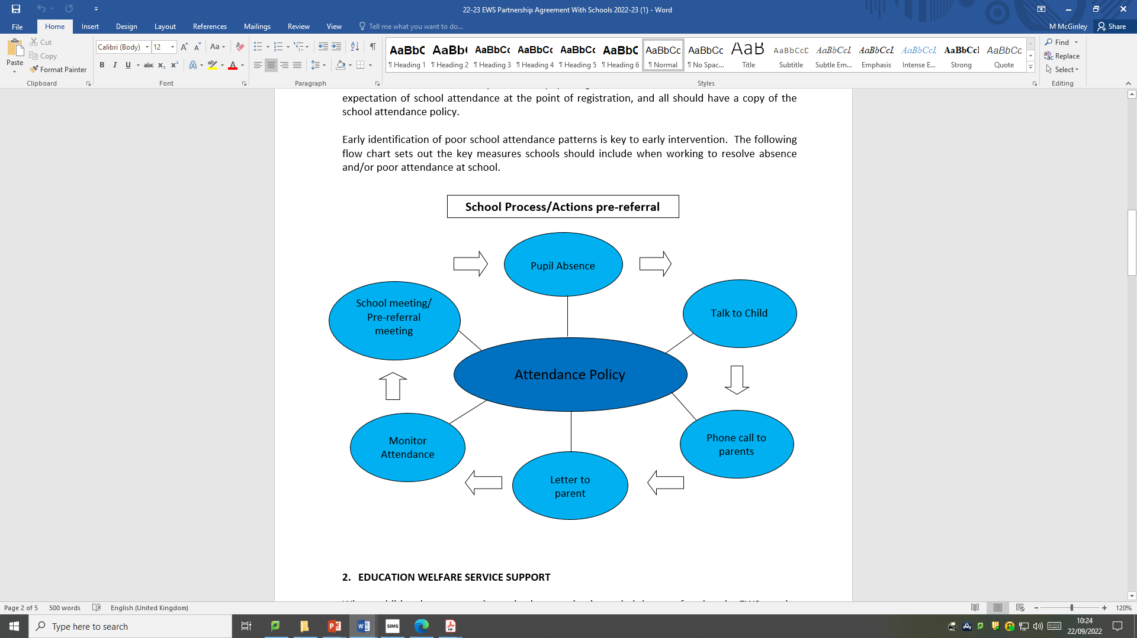

Figure 1

A child’s attendance level drops below 85%. Senior Leadership Team will consult SIMS records to determine the reason for the low level of attendance.

Figure 2 Process if attendance continually fails to improve

The electronic register system (SIMS) provides many reports and information that assist the school to monitor attendance. These reports will be accessed when relevant and provide information to assist the school strategically manage attendance issues.

The EWO will also have access to this information and will use the reports to support their role.

**Official Register**

The register is stored electronically on the SIMS system which also contains an audit trail of any changes for each child’s registration. This is accessed in school by those with specific permissions (Principal/VP/Secretaries) and the data is protected by the DE SIMS information system.

**Strategies used to promote good attendance and punctuality**

* Class teacher will ensure that the curriculum is delivered within a culture of inclusion and in such a way that the pupils feel that they have and can succeed.
* Individual pupils whose attendance has been a cause for concern will be encouraged to set and achieve personal attendance goals.
* Pupil attendance figures will be published with the annual academic reports.
* Positive verbal reinforcement is given to pupils who have been absent from school for a period of time and an education plan developed to help them catch up with any missed curriculum and promote future attendance.

**Remote or Blended Learning**

In the event of children being unable to attend the school building due to unforeseen circumstances e.g. Lockdown restrictions, Covid outbreak, asbestos closure, malicious damage to the school building, the school will operate remotely for individual classes or the whole school as required.

The school will use MS TEAMS for years 4-7 and SeeSaw for years 1-3 to provide remote learning. Children will be marked present by:

* Year 4-7 children will engage in daily lessons via completion of the set assignments and attendance at virtual meetings.
* Year 1-3 children will submit work via SeeSaw.

At St Joseph’s we are aware of the many difficulties for parents/carers that remote learning poses and we will be realistic with our expectations. SLT will regularly check with class teachers about which children are engaging with remote learning. If concerns are raised by staff regarding a pupil’s engagement, members of the SLT will contact the parent/carer to offer support in terms of home booklets, IT equipment or encouraging the child to engage.

If there is no engagement, the school will provide a place for pupils in the school building, for supervised learning, under the vulnerable category.

**Education Welfare Service**

The Education Authority, through the Education Welfare Service (EWS), have a legal duty to make sure that parents/guardians meet their responsibility towards their children’s education. If a pupil’s absence causes concern, or if their attendance falls below 85% and there is also a concern, they will be referred to the EWS, if appropriate. EWS will support staff and parents in developing and implementing strategies to address or improve school attendance.