Word Race  Set a timer for 1 minute. How many times can you write your spelling correctly? Repeat for each of your spellings. | Silly Sentences  Write a sentence using one or more of your words that is ridiculous. The sillier the better! | Dictionary Definitions  Use a dictionary to find the correct meanings of each of your spellings. | Noughts & Crosses  Take it in turns with a partner to ask each other how to spell your words. If correct you get a go.  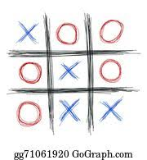
Synonyms & Antonyms  Use a thesaurus to find synonyms (words that mean the same or similar) and antonyms (words meaning the opposite) of your spellings. | Words within Words  How many other words can you find within each spelling?  e.g. together  there got  teeth here  her toe | Wordle  Create a wordle using your spelling words. This could be hand drawn or using http://www.wordle.net/create | Spelling Tennis  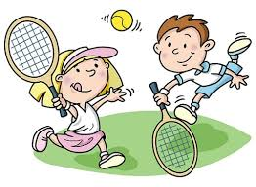  With a partner, take it in turns to say the letters or sounds in your word. You could challenge yourself by trying it backwards.

