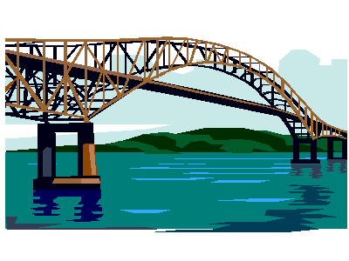
Bridges

What I know | What I want to know | What I have learned

