Literacy  Reading: Continue to read at home and take AR quizzes  https://ukhosted3.renlearn.co.uk/2235372/default.aspx  Monday: Spelling Activity:  Please refer to See Saw for Group Tasks  Tuesday: Grammar: Verbs – Past, Present, Future (regular and irregular)  Link:  https://www.youtube.com/watch?v=SXlSJpC4Ilo  AND  https://www.youtube.com/watch?v=QlZXd-m6Pdw  Please refer to See Saw for Group Tasks  Wednesday: Writing: Creative Writing  Group 1 Group 2 Group 3 Group 4  Stuck It was a warm sunny day Space Alien What can you see – Swimming Pool  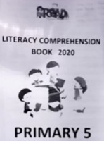  Thursday: Comprehension:  Please complete a comprehension from the ‘Literacy Comprehension Booklet’ – this booklet was sent home.  Friday: Friday Test  Ask an adult or sibling to test you!  Handwriting ‘The quick brown fox jumps over the lazy dog’ | Numeracy  Monday: Rounding to the nearest 10  Link: Corbett Maths Rounding to the nearest 10 - Primary  https://www.youtube.com/watch?v=QWsQ0RjCC5g  OR  Rounding to the Nearest 10  https://www.youtube.com/watch?v=wXPEUPjPFTE  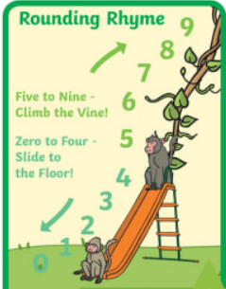  Please refer to See Saw for Group Tasks  Tuesday: Rounding to the nearest 100  Link: Corbett Maths Rounding to the nearest 100 - Primary  https://www.youtube.com/watch?v=2YpURODDiLc  OR  Link: Round Up and Down to The Nearest 10 Or 100 | Math | Grade 3 | Kids Academy  https://www.youtube.com/watch?v=VPdE5aOH52g  Please refer to See Saw for Group Tasks  Wednesday:  Times Tables Rock Stars or Numbots  Thursday: Calculating Perimeter  Link: Corbett Maths Perimeter  https://www.youtube.com/watch?v=6UCVcYnjBG4  Please refer to See Saw for Group Tasks  Friday: Weekly Challenge!  Ask an adult or sibling to test you! | Other Curriculum Areas  New Topic: Natural Disasters/ Extreme Earth  Earthquakes  Links:  Video: https://www.youtube.com/watch?v=Q-v-G1iL67w  Information:  https://www.coolkidfacts.com/earthquakes-for-kids/  We would like you to complete the following activities:  - Write five facts about earthquakes  - Research - Find out about an earthquake that has happened in the last 5 years.  Homework  Monday Reading Spellings Number facts  EIP day 113 MA S3 Test 5a MA Monday ABC order  Tuesday Reading Spellings Number facts  EIP day 114 MA S3 Test 5b MA Tuesday Rainbow  Wednesday Reading Spellings Number facts  EIP day 115 MA S3 Test 5c MA Wednesday V and C  Thursday Reading Spellings Number facts  EIP day 116 Calculations Practice Test

